Foundations of Programming

Lab Assignment No. : 03

PROBLEM STATEMENT:
Write a program in C to generate multiplication tables for a given number.
OBJECTIVES:
- To understand the use of looping statements in C.
- To generate multiplication tables using loops.
- To improve program logic and execution flow understanding.

THEORY:
1. Syntax for for loop example program
Ans. for(initialization ; condition ; increment)
{
body;
}
eg. for(int i=1;i<5;i++)
{
printf("%d",i);
}
2. Syntax for while loop example program
Ans. while(condition)
{
Body;
Increment;
}
eg. while(i<5)
{
printf("%d",i);
i++;
}
3. Syntax for do while loop example program
Ans. do {
Body;
increment;
} while(condition);
eg. do {
printf("%d",i);
i++;
} while(i<5);
ALGORITHM:
1. Start
2. Accept a number from the user and store in 'n'
3. Initialize i=1
4. Loop for as long as i<=10
a. Display, "n*i=(n*i)"
b. Increase value of 'i' by 1
5. Stop
Type Program (Multiplication table)
#include<stdio.h>
int main()
{
int n,i;
printf("Enter a number ");
scanf("%d",&n);
for(i=1;i<=10;i++)
printf("%d * %d = %d \n",n,i,(n*i));
}
PLATFORM:
Linux

INPUT:
Choice of number

OUTPUT:
Displays the multiplication table of the number entered
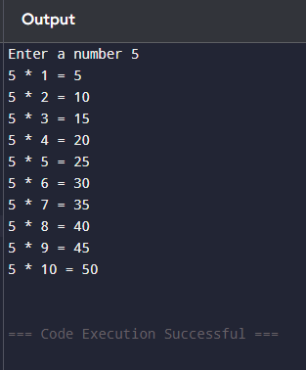
SAMPLE INPUT:
5
SAMPLE OUTPUT:
5 * 1 = 5
5 * 2 = 10
5 * 3 = 15
5 * 4 = 20
5 * 5 = 25
5 * 6 = 30
5 * 7 = 35
5 * 8 = 40
5 * 9 = 45
5 * 10 = 50
CONCLUSION:
Thus, the loops in C successfully help us print the multiplication table of any number

FAQs:
- Which loop is best suited for generating multiplication tables?
- What is the role of loop initialization?
- Difference between for loop, while loop and do while loop?
- Can a do–while loop be used to generate multiplication tables? Explain.
- Why is the do–while loop called an exit-controlled loop?

